**MOBILE BEST PRICE (MBP)**

**A Project Work**

*Submitted in the partial fulfilment for the award of the degree of*

**BACHELOR OF ENGINEERING**

**IN**

**CSE specialized in ARTIFICIAL INTELLIGENCE and MACHINE LEARNING**

**Submitted by:**

**PRATIBHA**

**18BCS6093**

**Under the Supervision of:**



**APEX INSITUTE OF TECHNOLOGY**

**CHANDIGARH UNIVERSITY, GHARUAN, MOHALI - 140413,**

**PUNJAB**

**JULY, 2019**

**DECLARATION**

I, **PRATIBHA**, student of **‘Bachelor of Engineering in CSE with specialisation in Artificial Intelligence and Machine Learning.’**, **session: 2018 - 2019**, Apex Institute of Technology, Chandigarh University, Punjab, hereby declare that the work presented in this Project Work entitled **‘MOBILE BEST PRICE (MBP)’** is the outcome of our own bona fide work and is correct to the best of our knowledge and this work has been undertaken taking care of Engineering Ethics. It contains no material previously published or written by another person nor material which has been accepted for the award of any other degree or diploma of the university or other institute of higher learning, except where due acknowledgment has been made in the text.

**PRATIBHA**

**Candidate UID: 18BCS6093**

**Date: 16 JULY, 2019**

**Place: CHANDIGARH UNIVERSITY**

**CERTIFICATE**

This is to certify that the work embodies in this dissertation entitled **‘MOBILE BEST PRICE (MBP)’** being submitted by **PRATIBHA , Roll Nos. – 18BCS6093** for partial fulfilment of the requirement for the award of **Bachelor of Engineering** in **CSE with specialisation in Artificial Intelligence and Machine Learning** discipline to Apex Institute of Technology, Chandigarh University, Punjab during the academic year 2018 - 2019 is a record of bonafide piece of work, undertaken by him/her the supervision of the undersigned.

**Approved and Supervised by**

**Signature of Supervisor:**

**(Supervisor's Name)**

**Designation, Department**

**Forwarded by**

**( Dr. Bhupinder Singh )**

**Professor & Head of Department**

**EXTERNAL EXAMINER**

**Signature of External Examiner**

**(External Examiner's Name)**

**ACKNOWLEDGWMENT**

I would like to convey my special thanks of gratitude to my **JAVA TEACHER** as well as **CO-ORDINATOR MAM** who gave me the golden opportunity to do this project on the topic **MOBILE BEST PRICE CALCULATOR.**  This project helped me in doing lots of research for the project which taught me many new things.

Secondly I would like to thank my parents and friends for all their support and ideas which leads the finalizing of this project within time frame.

**PRATIBHA**

**UID: 18BCS6093**

**ABSTRACT**

Mobile Best Price is a calculator which calculates the price of used mobiles by knowing its company, brand name, age and condition. So that you can find the best price of the used phone you want to sell or buy.

The methodology used in making of project includes firstly I tell you about how to calculate the price of used mobile phones theoretically using algorithms and this helps in building logic.

After that there are diagrams and flowchart to understand the concept better. Then we write the full java program with sample output using instant variables, if else and user defined method.

This project has helped me in learning java more thoroughly and this project is also the outcome of java we have learnt in institutional training provide by Chandigarh University. I am really thankful to the institution.

**-PRATIBHA**

**Student at Chandigarh University**

**TABLE OF CONTENTS**

Title Page 1

Declaration of the student 2

Certificate 3

Abstract 4

Acknowledgement 5

List of tables 7

1. Introduction 8

1.1 Problem Definition 8, 9

1.2 Project Overview/Specifications 9, 10

1.3 Hardware Specification 10

1.4 Software Specification 10

2. LITERATURE SURVEY 11

2.1 Existing System 11

2.2 Proposed System 11

3. SYSTEM ANALYSIS & DESIGN 12

3.1 Design and Test steps 12

3.2 Testing Process 13

4. RESULTS / OUTPUTS 14

5. CONCLUSIONS / RECOMMENDATIONS 15

6. REFERENCES 15

**LIST OF TABLES**

**CONTENTS PAGE No.**

**1. Table (A) :** condition Excellent 9

**2.** **Table(B) :** condition Good 9

**3.** **Table(C) :** condition Fair 10

1. **INTRODUCTION**
   1. **Problem Definition:**

MOBILE BEST PRICE is about calculating best price of a used mobile phone so that we can buy or sell the same at a fair market price. This project will help in getting us the fair market price of a second hand mobile phone which is very necessary as there are chances that someone may ask for false price. So if you MBP you can demand the real price. This project is developed in java using instant variables, if else loops and user defined method.

* 1. **Project Overview:**

Mobile Best Price is an algorithmic java based project which gives the estimated market price of any used mobile phone. It asks the user to enter the phone’s company name, model name, age and condition of the mobile phone based on its age. Then it calculates the market price based on all this factors. MBP aware you about the specifications of the mobile phone.

* + 1. **How does it work?**
* Program firsts ask the user to select the name of the company of which the user wanted to buy or sell the mobile phone.
* After selecting the company name the program shows you the list of all the main models that belong to that company and ask user to select which model he or she wants.
* After selecting the model name it asks the user to select the age of the mobile phone. It uses the concept that less the mobile phone age is more the price of that mobile phone. If the age of the phone is between 0 to 6 months it tells you the price according to that considering that the condition of the mobile phone would be okay. If the age of the mobile is between 6 to 12 months or above than that then it will first ask the user about the condition of the phone and then it will tell you the price.
* With the price of the mobile phone it also shows up the specifications of the mobile phone.
  + 1. **SPECIFICATIONS**

How to determine condition of the mobile phone:

* EXCELLENT:

|  |  |
| --- | --- |
| **FACTORS** | **CONDITION: EXCELLENT** |
| SCREEN | FLAWLESS(NO SCRATCHES) |
| WATER DAMAGE | NO |
| CAMERA AND VEDIO | NO SCRATCHES OR DAMAGE |
| COLOR DISPLAY | NORMAL |
| BATTERY CONDITIION | EXCELLENT |
| ANY OTHER DAMAGES (such as jacks, on-off or volume buttons, etc.) | NO OTHER DAMAGES |

**TABLE (A)**

* GOOD:

|  |  |
| --- | --- |
| **FACTORS** | **CONDITION: EXCELLENT** |
| SCREEN | MINOR SCRATCHES |
| WATER DAMAGE | NO |
| CAMERA AND VEDIO | NO SCRATCHES OR DAMAGE |
| COLOR DISPLAY | NORMAL |
| BATTERY CONDITIION | GOOD |
| ANY OTHER DAMAGES (such as jacks, on-off or volume buttons, etc.) | NO OTHER DAMAGES EXCEPT EARPHONE JACK IS NOT WORKING PROPERLY. |

**TABLE(B)**

* FAIR:

|  |  |
| --- | --- |
| **FACTORS** | **CONDITION: EXCELLENT** |
| SCREEN | MODERATE SCRATCHES |
| WATER DAMAGE | YES |
| CAMERA AND VEDIO | NO SCRATCHES OR DAMAGE |
| COLOR DISPLAY | NOT NORMAL |
| BATTERY CONDITIION | GOOD |
| ANY OTHER DAMAGES (such as jacks, on-off or volume buttons, etc.) | EARPHONE AND CHARGER JACKS ARE NOT WORKING. |

**TABLE(C)**

* 1. **HARDWARE SPECIFICATIONS:**
* Lenovo Ideapad 330
* Intel core i3-8130U(8th Gen)
* 2.2 Ghz
* Hard Disk : 1 TB
* RAM : 4 GB
  1. **SOFTWARE SPECIFICATIONS:**
* OPERATING SYSTEM: Windows 10 Home Basic
* OS TYPE: 64-bit

1. **LITERATURE SURVEY**
   1. **EXISTING SYSTEM:**

Existing system of finding price of used mobiles are seeing many regressions because they are past data based pricing engines. This engines are enable to tell the fair market price because they all are based on past data and methodology. This shows that there is an important need of a engine which is based on latest data and algorithms.

* 1. **PRPOSED SYSTEM:**

Firstly the proposed system is based on latest data and models. The list of models include are launched between past 2 or 3 years mainly and they are among the most popular. This makes this model more efficient. Latest actual market price of each model is inserted so that it can fairly calculate the fair market price of each used phone. This is a model of MBP but we can include many other data and models in it to make it successful.

1. **SYSTEM ANALYSIS AND DESIGN**
   1. **DESIGN AND TEST STEPS:**
2. **SELECT COMPANY NAME:**

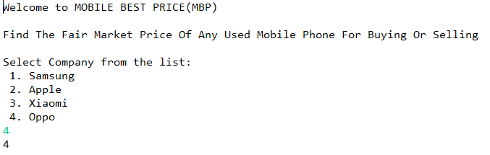

1. **SELECT MODEL:**

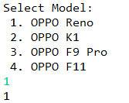

1. **SLECT AGE OF PHONE:**

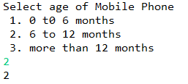

1. **SELECT CONDITION AND FAIR MARKET PRICE:**

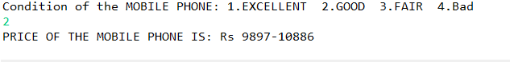

* 1. **TESTING PROCESS:**
* Program firsts ask the user to select the name of the company of which the user wanted to buy or sell the mobile phone.
* After selecting the company name the program shows you the list of all the main models that belong to that company and ask user to select which model he or she wants.
* After selecting the model name it asks the user to select the age of the mobile phone. It uses the concept that less the mobile phone age is more the price of that mobile phone. If the age of the phone is between 0 to 6 months it tells you the price according to that considering that the condition of the mobile phone would be okay. If the age of the mobile is between 6 to 12 months or above than that then it will first ask the user about the condition of the phone and then it will tell you the price.

**OUTPUTS AND RESULTS**

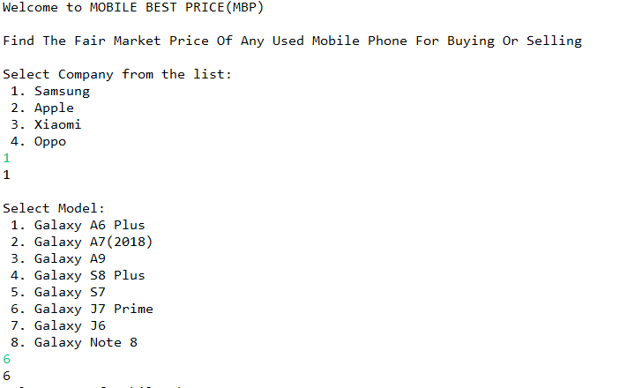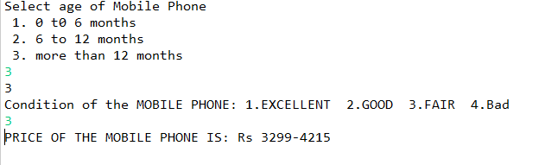

1. **CONCLUSION**

This project is really very helpful in knowing the best price of a second hand phone. Indians generally think of buying second hand phones instead of buying a new one. So selling and buying of a used phone becomes fair with this project. This can be developed further more with time to make it more reliable and efficient.

This project uses algorithms and logic which tells you the fair market price of any used phone by knowing its company name, model name, age and condition according to age. If you want to see how to decide condition of the phone you can check the specifications in table(A), table(B) , table(C).

This project tells you the range between you can buy or sell the mobile phone.

1. **REFERENCES**
2. Orange Book Value: this is a app which tells the fair market price of used vehicles.
3. <https://gadgets.ndtv.com> (for finding actual market price of each mobile phone)
4. Olx : an app which allow to buy or sell used things.